**UNIT I**

**MS-WORD**

**1.1 INTRODUCTION TO WORD**

* Under Word Processing comes the typing, saving and printing of document etc. The system helping the word processing in its work is known as Word Processor.
* Word processor is the system helping us in the process of typing of a document, converting it, saving it and printing it. It helps us in many ways such as Letter Drafting, producing mailing list, report etc.
* Microsoft Word is a word – processor that is designed to help us work more efficiently. Within Microsoft Word, we can display more than one document at a time. We can arrange windows on screen as papers on our desk.
* **Special Features**   
  1. Word Adjusting   
  2. Add and delete Text   
  3. Copying a Text   
  4. Search and Replace   
  5. Checking a document   
  6. Character formatting   
  7. Page formatting   
  8. Margin setting and column   
  9. Text justification   
  10. Line spacing   
  11. Tab setting
* Word Processors in Window environment are: Microsoft word, Word Perfect, Word Star, Ami Professional, Write/Word Pad.

**1.1.1 STARTING MS-WORD**

* MS word can be started by any one of following three methods:

1. By double click over ‘Microsoft word’ icon on the desktop.
2. (a) Click on Start’ Button.   
    A list will open.   
    *(b)* Point to ‘Programs’ option.   
    A list will open again.   
    *(c)* Click on 'Microsoft word’ option. MS Word will start.   
   3. (a) Click over ‘Microsoft word’ icon on the desktop. The colour of ‘Microsoft word’ icon will change.   
    *(b)* Right click on this icon - A list will open.   
    *(c)* Click on 'Open’ option.   
    MS Word will start.

* As soon as MS Word started, following window will appear on the screen:

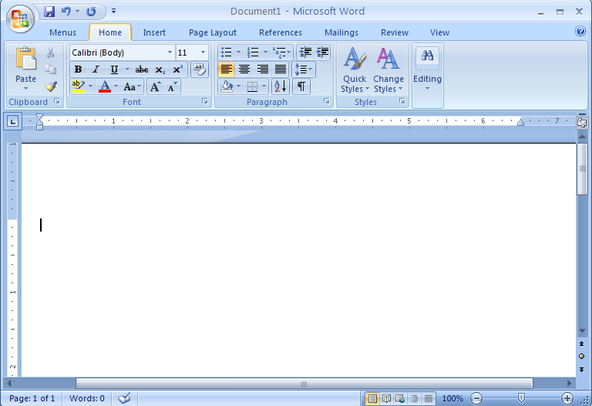

* **PARTS OF WORD WINDOW**

**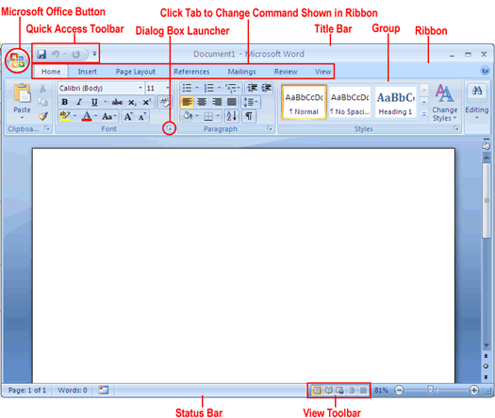**

1. Click the Microsoft Office Button. 

Commands related to managing documents are available from the menu that opens (creating, saving and printing). This menu is referred as **Office Menu**, takes the place of the File menu that appeared in previous versions of Word.

1. Press the Esc key to close the menu.

On the Ribbon, the Home Tab is active. Buttons are organized on this tab in five groups: Clipboard, Font, Paragraph, Styles and Editing.

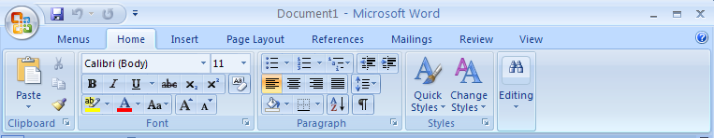

1. Hover the mouse pointer over the active buttons on this tab to display the screen tips.

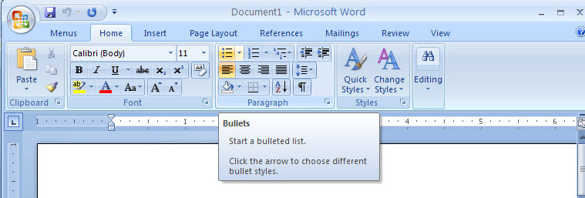

1. Click the **Insert** Tab, and then explore its buttons.

Buttons are organized on this tab in seven groups: Pages, Tables, Illustrations, Links, Header & Footer, Text and Symbols.

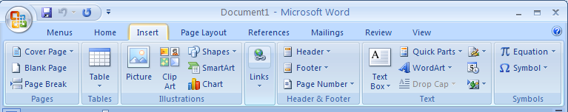

1. Click the **Page Layout tab** (appearance), and then explore its button.

Buttons are organized on this tab in five groups: Themes, Page Set up, Page Background, Paragraph and Arrange.

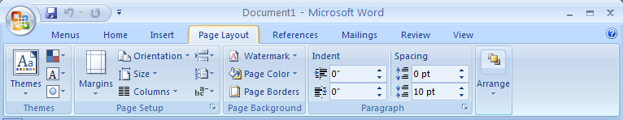

1. In the Page Setup group, display the Screen Tip for the Margins button.

It tells us how we can adjust the margins.

1. At the right end of the Page Setup group’s title bar, click the Page Setup dialog Box Launcher. The Page setup dialog box opens.
2. Click cancel to close the dialog box.
3. In the Themes group, click the Themes button.
4. Press Esc to close the gallery without making a selection.
5. In the Page Background group, click the page color button, and then in the top row of the Theme colors palette, point to each box in turn.
6. Press esc to close the palette without making a selection.
7. Click the **References tab**, and then explore its buttons.

Buttons are organized on this tab in six groups: Table of contents, Footnotes, Citations & Bibliography, Captions, Index and Table of Authorities.

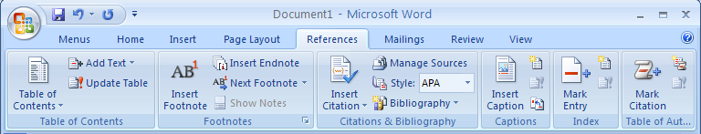

1. Click the **Mailings tab** (creating mass mailings), and then explore its buttons.

Buttons are organized on this tab in five groups: Create, Start Mail Merge, Write & Insert Fields, Preview Results and Finish.

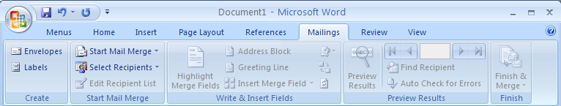

1. Click the **Review tab** (proofing commenting and changing), and then explore its buttons.

Buttons are organized on this tab in six groups: Proofing, Comments, Tracking, Changes, Compare and Protect.

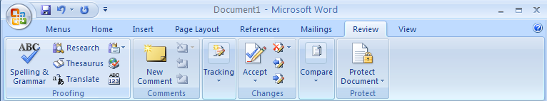

1. Click the **View Tab** (changing the view or display), and then explore its buttons.

Buttons are organized on this tab in five groups: Document views, Show/Hide, Zoom, Window and Macros.

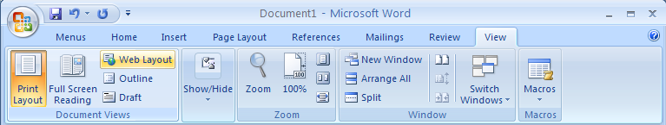

**1.1.2 CREATING DOCUMENT IN WORD**

* To creating a document in MS Word follow these steps:

1. Click on ‘Office Button’ menu.

A drop down list will open.

1. Click on ‘New’ option in this drop down list.

‘New’ dialog box will open.

1. Select ‘Blank Document’ and click on ‘OK’ button.

A window will appear in which we can do typing work. See following figure:

|  |  |
| --- | --- |
|  |  |

* + 1. **SAVING A DOCUMENT IN WOR**
* To saving a document follow these steps:

1. Click on ‘Save’ button in ‘Microsoft Office’ menu.

‘Save As’ dialog box will appear.

1. Type filename in the box ‘File name’ and click on save button.

The document will save.

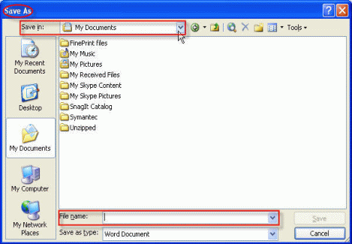

**1.1.4 PREVIEWING DOCUMENTS**

* ‘Print Preview’ option gives us preview of the printout. To see ‘Print Preview’ of document follow these steps:

1. Click on ‘Microsoft Office’ menu. A drop-down list will open.
2. Click on ‘Print Preview’ option. Print preview of desired page will appear on the screen. See following figure.

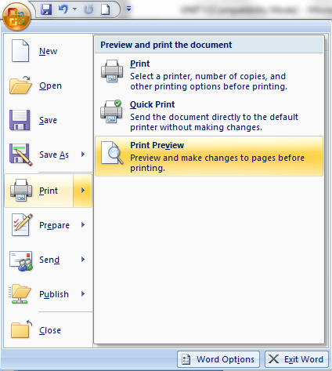

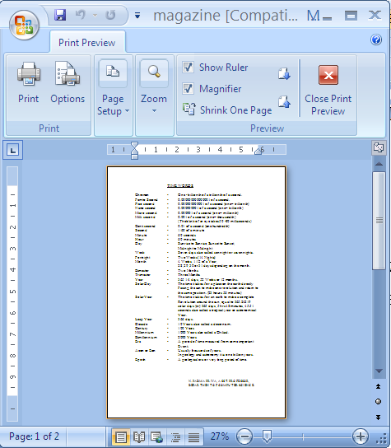

**1.1.5** **PRINTING A DOCUMENT**

1. Open desired document for printing.
2. Click on ‘Microsoft Office’ menu. A drop-down list will open.
3. Click on ‘Print’ option. Print dialog box will appear on the screen. See following figure.

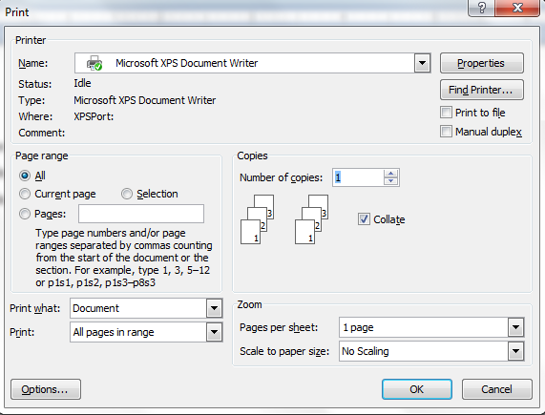

1. Select desired options in ‘Print’ dialog box and click on ‘OK’ button. Printing of document will start.

**1.1.6 CLOSING A WORD**

* Both Ctrl-W and Ctrl-F4 will close the current document without closing Word itself.
* If more than one document is open, we can close it by clicking the Close button at the right end of the title bar.
* If only one document is open, clicking the Close button closes the document and also quits the word.
* If we want to close the document but leave word open, we must click the Microsoft Office Button and then Click Close.

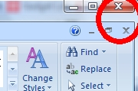

* 1. **EDITING A DOCUMENT**

**1.2.1 OPENING A DOCUMENT**

* To open a document, follow these steps:

1. Click on ‘Open’ button in ‘Microsoft Office’ menu.

‘Open’ dialog box will appear.

1. Select desired document from the given list and click on ‘Open’ button

The desired document will open.

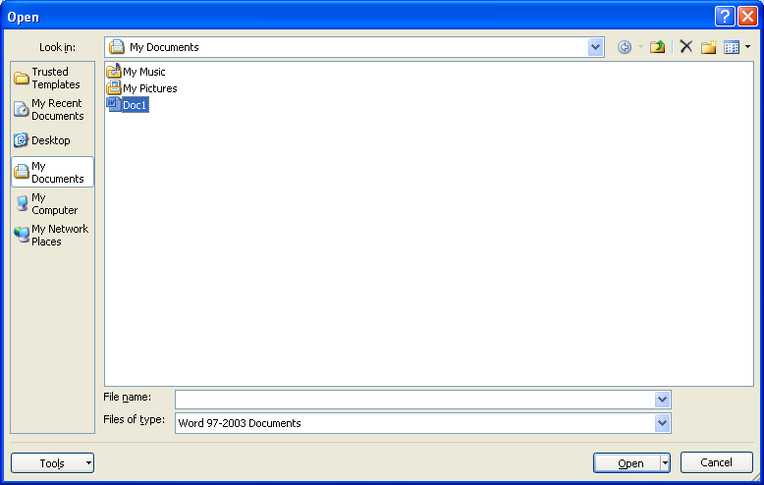

**1.2.2 CURSOR MOVEMENT**

* **Moving, Scrolling in a Document**
* With the help of Mouse Pointer and Insertion Point we can move within any part of document. Their descriptions are as follows:
* **Mouse Pointer:** It is in the form of a large I. We can move it anywhere on the screen. It changes its shape in other part of window. We can see it only when at is lying within text area.
* **Insertion Point:** It is called cursor of document. It is in the form of a large line ‘|’. Any typed text is inserted in text area with the help of it. Cursor can reach anywhere in text area by clicking once. See following figure:

****

* With the help of Scroll Bar and arrow buttons can move document either up-down or left-right.

**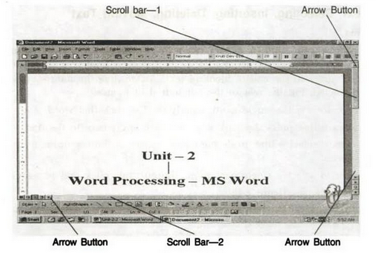**

**1.2.3 EDITING TEXT: SELECTING, INSERTING, DELETING**

* **Selecting Text**

1. In order to select a block of text, place the mouse cursor at the beginning of the block of text, press the left button or mouse (and hold it down), and drag the mouse cursor to the end of block of text. As we drag the mouse cursor the text gets selected. Finally, release the left button of mouse.
2. In order to select a single word, simply double click that word.
3. To select a line press the ‘Ctrl’ key and click anywhere in the line.
4. In order to select a line, place the mouse cursor at the beginning of the line and click once.
5. In order to select a single paragraph, simply triple click that paragraph. For example,

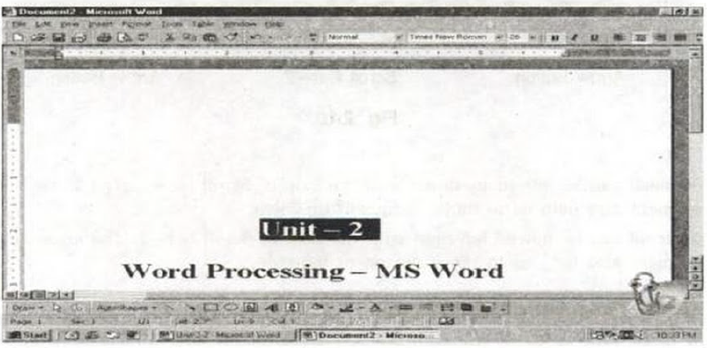

* **Inserting Text**
* To insert new text anywhere in the old text, place the insertion point at desired location and start required typing.

|  |  |
| --- | --- |
| C:\Users\priya\AppData\Local\Temp\msohtmlclip1\01\clip_image001.png | C:\Users\priya\AppData\Local\Temp\msohtmlclip1\01\clip_image001.png |

* **Deleting Text**
* To delete a text or part of a text from a document, follow these steps:

1. Select desired part for deleting.
2. Press 'Delete' button from keyboard.

* Selected text or part of a text will delete. For example, see fig (a) and fig (b). Selected part of text in fig (a) is not available in fig (b)

|  |  |
| --- | --- |
| C:\Users\priya\AppData\Local\Temp\msohtmlclip1\01\clip_image001.png | C:\Users\priya\AppData\Local\Temp\msohtmlclip1\01\clip_image001.png |
| **Fig (a)** | **Fig (b)** |

# UNDO AND REDO IN WORD

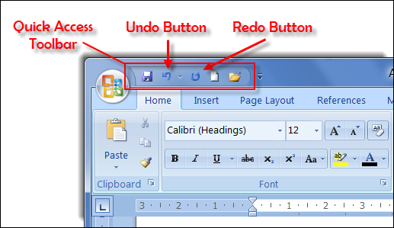

## The Undo command

* The Undo command undoes anything you do in Word, such as formatting text, moving blocks, typing and deleting text, formatting — all of it.
* Undo command in two handy ways:

1. Press Ctrl+Z.
2. Click the Undo command button on the Quick Access Toolbar.

* An advantage of using the Undo command button is that it sports a drop-down menu that helps you review the past several things you’ve done, or that can be undone.

## Redo, the Undo-Undo command

* You may type some text and then use Undo to “untype” the text. You can use the Redo command to restore the typing. You have two choices:

1. Press Ctrl+Y.
2. Click the Redo command button on the Quick Access Toolbar

* The Redo command serves two functions:
* It does exactly the opposite of whatever the Undo command does. So, if you type text, Undo untypes the text, and Redo recovers the text.
* If you use Undo to recover deleted text, Redo deletes the text again.
  + 1. **MOVING TEXT**
* To move some part of a text, follow these steps:

1. Select desired part of text to be moved.
2. Place the mouse pointer in selected area.
3. Press left button and hold it.
4. Drag the cursor at desired place.
5. Release the left button of mouse.

* Selected part of a text will move from one place to another place. See fig (a) and fig (b).

|  |  |
| --- | --- |
| C:\Users\priya\AppData\Local\Temp\msohtmlclip1\01\clip_image001.png | C:\Users\priya\AppData\Local\Temp\msohtmlclip1\01\clip_image001.png |
| **fig (a)** | **fig (b)** |

* **Move Action Keystroke**
* Beginning of the line **HOME**
* End of the line **END**
* Top of the document **CTRL+HOME**
* End of the document **CTRL+END**
* Move in a blank document **Tab, Enter and space bar**
  + 1. **CUT, COPY AND PASTE TEXT**

1. **Type Text**: Put your cursor where you want to add the text and begin typing
2. **Copy and Paste Text**: Highlight the text you wish to copy and right click and click

**Copy**, Or hold down the CTRL and the “C” key at the same time, put your cursor where you want the text in the document and right click and click **Paste**., or Ctrl + V (hold down the CTRL and the “V” key at the same time) or use the Clipboard group to Paste, Paste Special, or Paste as Hyperlink



1. **Cut and Paste Text**: Highlight the text you wish to copy and right click and click **Cut**, put your cursor where you want the text in the document and right click and click **Paste**.
2. Also use the Clipboard group on the **Home Tab** of the Ribbon.

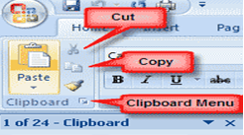

**1.2.7 GETTING HELP WITH OFFICE**

* **Asking the Assistant for Help**
* What sets Office Assistant apart from other help features is that you can use simple to ask for assistance.
  1. **FORMATTING TEXT**
* **STYLES**
* A style is a format enhancing tool that includes font typefaces, font size, effects (bold, italics, underline, etc.), colors and more.
* Home Tab of the Ribbon, that you have several areas that will control the style of your document: Font, Paragraph, and Styles.



* **USING FONT TO** **FORMATTING TEXT**
* To change the font typeface:
* Click the **arrow** next to the font name and choose a font.



* Click here once to get a pull down list of all the fonts available to you choose the “Times New Roman” font by clicking on it.

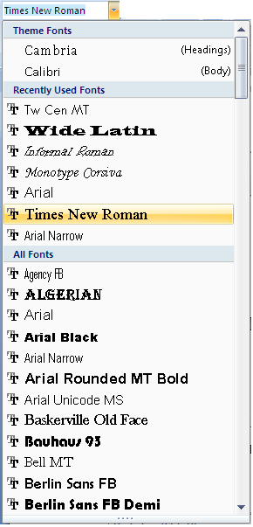

* **FONT FACE** Click the arrowhead to the right of the font name box to view the list of fonts available. Scroll down to the font you want and select it by clicking on the name once with the mouse. The following graphic demonstrates the difference between SERIF and SANS-SERIF fonts.



* **FONT SIZE** Click on the white part of the font size box to enter a value for the font size or click the arrowhead to the right of the box to view a list of font sizes available. Select a size by clicking on it once. A font size of 10 or 12 is best for paragraphs of text.

**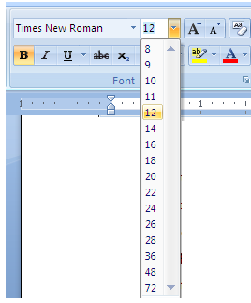**

**Increasing Font Size**

Click here once to increase the font size to which size we want.

* **FONT COLOR**
* To change the text color:
* Select the text and click the **Colors** button included on the Font Group on the **Home Tab** of the Ribbon, or highlight the text and right click and choose the colors tool.
* Select the color by clicking the down arrow next to the font color button.



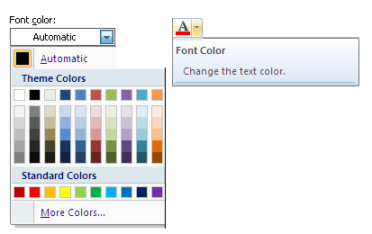

* **FONT STYLE** Use these buttons to bold, italicize, and underline text.

**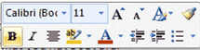**

**BOLD**

***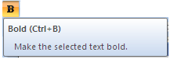***

* Now since we want to Bold only the word at the touch of a button and not the entire heading, highlight only this portion, leaving out the word and click once on the Bold icon.

**ITALIC**

**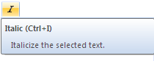**

* Now since we want to Italicize only the word at the touch of a button and not the entire heading, highlight only this portion, leaving out the word and click once on the Italics icon.

**UNDERLINE**

**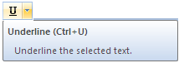**

* Now highlight the entire heading once again and click on the underline icon to apply underline style.
* **HIGHLIGHT COLOR:**

****

* Highlighting text allows you to use emphasize text as you would if you had a marker.
* To highlight text:
* Select the text
* Click the **Highlight Button** on the Font Group on the **Home Tab** of the Ribbon, or
* Select the text and right click and select the highlight tool
* To change the color of the highlighter click on down arrow next to the highlight button, Then choose the suitable one.
* **COPY FORMATTING**
* If you have already formatted text the way you want it and would like another portion of the document to have the same formatting, you can copy the formatting.

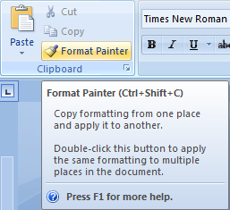

* To copy the formatting, do the following:
* Select the text with the formatting you want to copy.
* Copy the format of the text selected by clicking the **Format Painter** button on the clipboard Group of the Home Tab
* Apply the copied format by selecting the text and clicking on it.
  1. **FORMATTING PARAGRAPH**
* **Aligning Text and Paragraph**
* Word supports four types of paragraph alignments.

1. Left Alignment - Left margin
2. Center Alignment - Center
3. Right Alignment - Right margin
4. Justify - Left and Right margin

* The left alignment is the default one.

**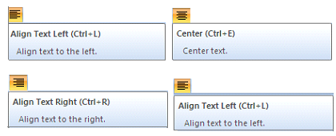**

* To do above work, follow these steps:

1. Select the paragraph for formatting.
2. Click on required alignment button.

* For example, see fig (a) and fig (b). Here justify alignment is used.

|  |  |
| --- | --- |
| C:\Users\priya\AppData\Local\Temp\msohtmlclip1\01\clip_image001.png | C:\Users\priya\AppData\Local\Temp\msohtmlclip1\01\clip_image001.png |
| **fig (a)** | **fig (b)** |

* **Indent Paragraphs**
* Indenting paragraphs allows you set text within a paragraph at different margins. To indent paragraphs can do the following:
* Click the **Indent** buttons to control the indent.
* Click the I**ndent** button repeated times to increase the size of the indent.



* Click the dialog box of the **Paragraph** Group
* Click the **Indents and Spacing** Tab
* Select your indents



* **Using Bullets and Numbers in Paragraphs**
* Bulleted lists have bullet points, numbered lists have numbers, and outline lists combine numbers and letters depending on the organization of the list.
* To **add** a list to existing text:
* Select the text you wish to make a list
* From the Paragraph Group on the Home Tab, Click the **Bulleted or Numbered Lists** button



* To **create** a new list:
* Place your cursor where you want the list in the document
* Click the **Bulleted or Numbered Lists** button
* Begin typing
* **BULLETED LIST**

### Adding Text to the List

### Add information to a list item but do not want to create a separate list item. Using this simple keystroke will place your insertion point on the next line without a bullet appearing.

1. Place the insertion point after the last character in the list item where you want to add text
2. Press [**Shift**] + [**Enter**]  
   The insertion point appears under the previous list item.  
   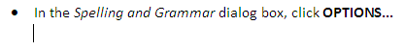
3. Type the additional text

## Customizing Bulleted Lists

* Customizing your bulleted list allows you to use creative and eye-catching bullets.
* Word provides many different images from which to choose. The following instructions assume that a bulleted list has already been created.

1. Select the bulleted list you want to customize
2. On the Homecommand tab, in the Paragraph group, clickon the **BULLETS** button  
   The Bullets pull-down menu appears  
   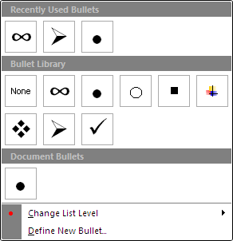
3. Select the desired bullet option
4. If the desired option does not appear, select ***Define New Bullet...***The Define New Bullet dialog box appears  
   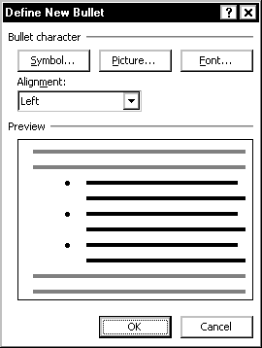
5. To select a symbol for your bullet,
   1. Under Bullet character, click **SYMBOL...** The Symbol dialog box appears.
   2. From the Font pull-down box, select the desired font
   3. In the scroll box, select the desired bullet character
   4. click **OK**
6. To select a picture for your bullet,
   1. Under Bullet character, click **PICTURE...**The Picture Bullet dialog box appears.
   2. In the scroll box, select the desired bullet character Click **OK**

* **NUMBERED LIST**

### Adding Text to the List

* Perhaps you want to add information to a step but do not want to create a separate list item. Using this simple keystroke will place your insertion point on the next line without a number appearing.

1. Place the insertion point after the last character in the step where you want to add text
2. Press [**Shift**] + [**Enter**]  
   Your insertion point appears under the previous list item.  
   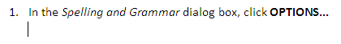
3. Type the additional text

## Customizing Numbered Lists

* Customizing your numbered list allows you to have a wider variety of styles for numbers.
* Word provides several different ways of customizing your numbers in order to create an effective numbered list. The following instructions assume that a numbered list has already been created.

1. Select the numbered list you want to customize
2. On the Home command tab, in the Paragraph group, clickon the NUMBERING button. The Numbered List pull-down menu appears.  
   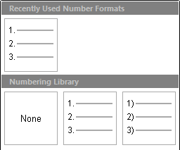
3. Select the desired numbering option
4. If the desired option does not appear, select ***Define New Number Format...***The Define New Number Format dialog box appears.

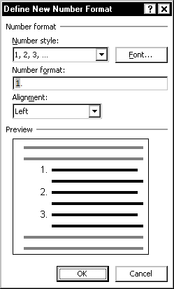

1. To change the number style, from the Number style pull-down list, select the desired option
2. To change the number format, in the Number format text box, make the desired changes  
   EXAMPLE: Instead of following numerals with a period (1.), you may want to follow them with a dash (1-).
3. To change the numbering alignment, from the Alignment pull-down list, select **Left**, ***Right*** or ***Centered***

|  |  |  |
| --- | --- | --- |
| **Left-aligned** | **Centered** | **Right-aligned** |
| Left aligned numbered list | Centered numbered list | Right aligned numbered list |

1. To change font, style, color, or size of the numbers,
   1. Click **FONT...**  
      The Font dialog box appears.
   2. Under Font, Font style, Font color, or Size, select the appropriate options  
      An example of your number formatting appears in the Preview section.
   3. Click **OK**  
      Your customized number appears in the Number format text box.
2. Click **OK**

### Changing the Starting Number

1. Select the numbered list
2. On the Home command tab, in the Paragraph group, clickon the NUMBERING button, The Numbered List pull-down menu appears
3. Select ***Set Numbering Value...***  
   The Set Numbering Value dialog box appears.  
   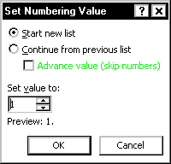
4. In the Set value to scroll box, type or use the nudge buttons to select the number to start the numbered list
5. Click **OK**

* **LINE SPACING:**
* To add a space between the lines

**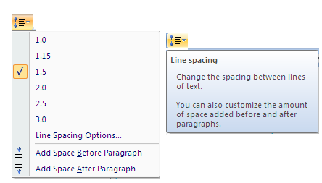**

* **OUTSIDE BORDER:**
* Add a border around a text selection.

**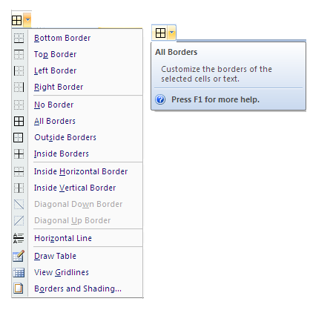**

* 1. **FINDING & REPLACE TEXT AND** **SPELLING CHECKING**

**1.5.1 FIND AND REPLACE**

* **Using Find**

1. Open any document.
2. Windows: From the Home command tab, in the Editing group, click **FIND** or Press [**Ctrl**] + [**F**] The Find and Replace dialog box appears, with the Find tab displayed. Click on find, the dialog box will be appearing.

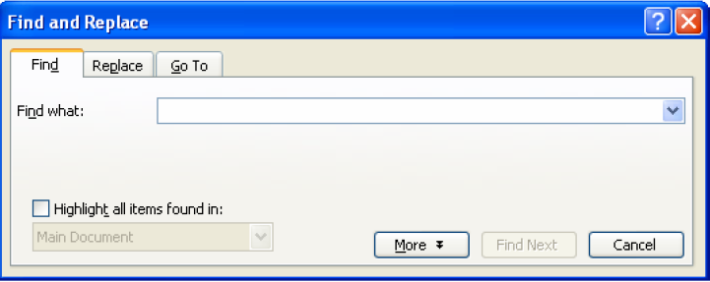

1. Type the word or phrase you want to locate.
2. Click on Find Next. Word will take you to the first occurrence of the search word or phrase.
3. Click on Find Next again. Word will take you to the text occurrence of the word or phrase that you’re looking for.
4. Click on OK.
5. Click on Cancel.

* **Finding All Occurrences**
* Word ability to find and highlight at occurrences of your search text.
  1. [Access the Find and Replace dialog box](https://www.uwec.edu/help/Word07/find-replace.htm#accessfind)
  2. In the Find what text box, type the text you want to search for
  3. To set [advanced options](https://www.uwec.edu/help/Word07/find-replace.htm#options) ,Click **MORE >>** Select the desired options
  4. Click **FIND IN** » select **Main Document**
  5. Click **FIND ALL,** All occurrences of the text are highlighted.
  6. To close the Find and Replace dialog box, click **CLOSE or** Click **CANCEL**

### Highlighting All Occurrences

* This option will highlight all occurrences of your text until you choose to clear the highlighting

***To highlight all occurrences:***

1. [Access the Find and Replace dialog box](https://www.uwec.edu/help/Word07/find-replace.htm#accessfind)
2. In the Find what text box, type the text you want to search for
3. To set [advanced options](https://www.uwec.edu/help/Word07/find-replace.htm#options)
   1. Click **MORE >>**
   2. Select the desired options
4. Click **READING HIGHLIGHT** » select **Highlight All**   
   All occurrences of the text are highlighted in yellow.

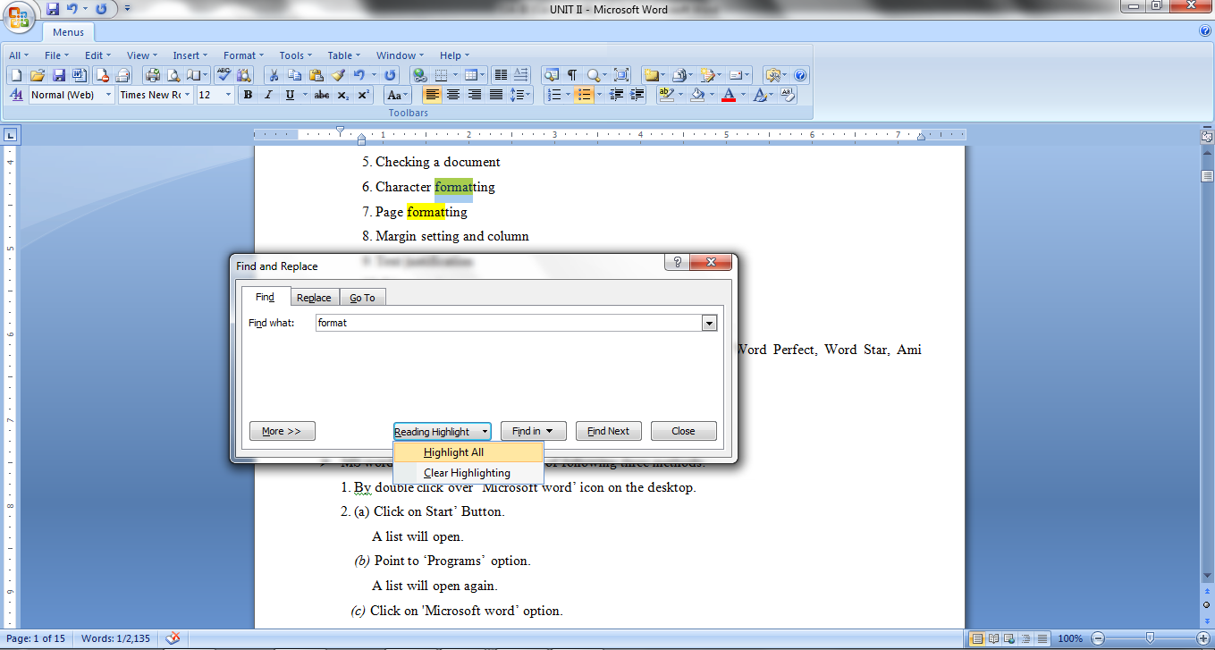

1. To close the Find and Replace dialog box, click **CLOSE or** Click **CANCEL**

#### To clear all highlighting:

1. [Access the Find and Replace dialog box](https://www.uwec.edu/help/Word07/find-replace.htm#accessfind)
2. Click **READING HIGHLIGHT** » select **Clear Highlighting**   
   All highlighted text returns to normal.
3. To close the Find and Replace dialog box, click **CLOSE or** Click **CANCEL**

* **Using Replace**
* If to locate text and change it to something else, let Word do it with the Replace feature.

1. Windows: From the Home command tab, in the Editing group, click **REPLACE****or**Press [**Ctrl**] + [**H**] The Find and Replace dialog box appears.
2. Click on Replace. The Find and Replace dialog box will open.

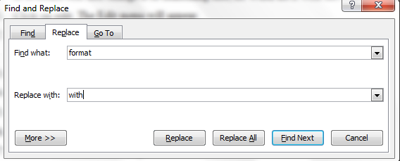

1. Type the text for the search.
2. Click in the Replace With text box.
3. Type a replacement word or phrase.
4. Click on Find Next.
5. Choose one of the following:
   * **Replace.** The text will be replaced and Word will highlight the next match.
   * **Replace All.** All occurrences of the found text will be replaced with the new text and you will be notified of the total number of replacements.
   * **Find Next.** Word will not make any changes to this occurrence and will jump to the next occurrence of the text.
6. Click on OK.
7. Click on Close.

**1.5.2 CHECKING THE GRAMMAR AND SPELLING**

* Word has built-in dictionaries and grammatical-rule sets to check your document.
* Word can identify possible problems as you type, and it also can run a special spelling and grammar check to provide you with more information about the problems and tools for fixing them.
* **Checking Spelling**
* Word identifies problems right in your document as you type.
* Spelling errors have a red wavy line underneath them, whereas grammatical errors are indicated with a green wavy line.

1. Right-click on the questionable word.
2. Click on the correct spelling or grammatical suggestion.

* **Running a Spelling and Grammar Check**
* By default, Word can run both a spelling and grammar check at the same time.
* To check the spelling and grammar of a document

1. Place the cursor at the beginning of the document or the beginning of the section that

you want to check

1. Click the **Review** Tab on the Ribbon
2. Click **Spelling & Grammar** on the Proofing Group.



1. Click on Spelling and Grammar.
2. Click on the correct spelling if available.

****

1. Click on one of the following options:
   * **Ignore Once.** If you don’t want to correct this instance of the spelling, use this option.
   * **Ignore All.** Click on this option if you don’t want to correct any instances of the spelling.

* **Ignore Rule.** Clicking on this option all instances of the grammatical problem.
* **Change.** The suggested change will be made to this occurrence.
* **Next Sentence.** This option moves on to the next sentence, making no changes.

1. Click on OK. The message box will close.

**1.5.3** **USING THE THESAURUS**

* When you just can’t remember the word you need, the Thesaurus is in available.

1. Click on the word that you want to replace with a better one.
2. Click the **Review** Tab of the Ribbon
3. Click the **Thesaurus** Button on the Proofing Group.
4. The thesaurus tool will appear on the right side of the screen and you can view word options.



1. Click on a meaning.
2. Click on a word in the replace with Synonym text box that fits your document better than the original.
3. Click on Insert. The word will be replaced with the suggestion.

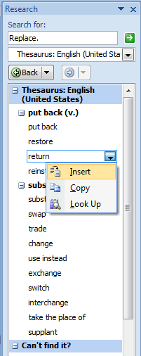

* + 1. **INSERTING DATE AND TIME**
* Many types of documents require the date. You may be working with a memo, a letter, a report, or some other document in which you must put the date.
* Word makes this easy by using the Date and Time option from the Insert menu. To insert the date, follow these steps:

1. Position the insertion point where you want the date to appear.
2. Display the Insert tab of the ribbon.
3. Click the Date & Time tool, in the Text group. Word displays the Date and Time dialog box.

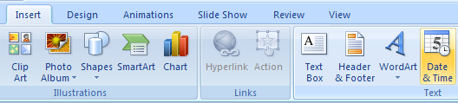

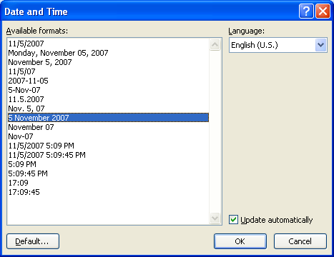

1. Select a format for the date.
2. Click on OK.

* If choose the "Update Automatically" check box a the bottom of the dialog box, the date is inserted as a field and it will always be updated to reflect the current date as you work on the document on future days.
* This can be very helpful if you are working with a letter template that you want to always be "in sync" with the day you write the letter.
* **Some Important Options in MS-WORD with shortcuts**

**NEW**: Creates a new document based ob normal template.

Alternative: MS Office Menu →New

Shortcut → Ctrl + N.

**SAVE**: Saves the active document or template

Alternative: MS Office Menu → Save.

Shortcut → Ctrl + S.

**PRINT**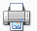: Prints the active document using current defaults.

Alternative: MS Office Menu → Print.

Shortcut → Ctrl + p.

**SPELLING**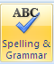: Checks the spelling in the active document .

Alternative: Review → Spelling and grammar.

Shortcut → F7.

**COPY**: Copies the selection and puts it on the clipboard.

Shortcut → Ctrl + C.

**FORMAT PAINTER**: Copies the formatting of the selection to a specified location.

Shortcut → Ctrl + Shift + c.

**OPEN**: Opens an existing document or template.

Alternative: MS Office Menu → Open.

Shortcut → Ctrl + O.

**PRINT PREVIEW**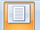: Displays full page as they are printed.

Alternative: MS Office Menu → Print Preview.

Shortcut → Ctrl + F2.

**CUT**: Cuts the selection and puts in on the clipboard.

Shortcut → Ctrl + X.

**PASTE**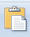: Inserts the clipboard contents at the insertion point.

Shortcut → Ctrl + V.

**UNDO**: Reverses certain commands.

Shortcut → Ctrl + Z.

**REDO**: Reverses the action of the undo command.

Shortcut → Ctrl + Y.

**INSERT TABLE**: Inserts a table.

Alternative: Table → Insert Table.

**SHOW/HIDE**: Shows/hides non-printing characters.

Shortcut → Ctrl + \*.

**OFFICE ASSISTANT:** Provides help topics and tips to accomplish your task.

Shortcut → F1.

**ZOOM CONTROL**: Scales the editing view (Zoom).

Alternative: View → Zoom.

Shortcut → Ctrl + S.

**STYLE:** Applies a style or records a style by example

Shortcut → Ctrl + Shift + S.

**FONT**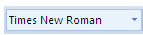: Changes the font of the selection.

Shortcut → Ctrl + Shift +F.

**FONT SIZE**: Changes the font size of the selection.

Shortcut → Ctrl + Shift + p.

**ITALIC**: Makes the selection italics.

Shortcut → Ctrl + I.

**ALIGN LEFT**: Aligns the paragraph at left indent.

Shortcut → Ctrl + L.

**ALIGN RIGHT**: Aligns the paragraph at right indent.

Shortcut → Ctrl + R.

**BOLD**: Makes the selection Bold.

Shortcut → Ctrl + B.

**UNDERLINE**: Formats the selection with continuous underline.

Shortcut → Ctrl + U.

**CENTER**: Centers the paragraphs between the indents.

Shortcut → Ctrl + E.

**JUSTIFY**: Aligns the paragraph at both right and left indent.

Shortcut → Ctrl + J.

**UNIT II**

**2.1 ENHANCING DOCUMENT**

**2.1.1 PAGE SETUP**

* MS-Word offers a variety of page layout and formatting options that affect how content appears on the page.
* You can customize the **page orientation**, **paper size**, and **page margins** depending on how you want your document to appear.

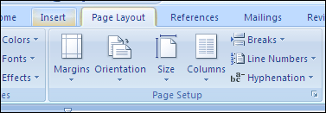

#### Page orientation

1. Select the **Page Layout** tab.
2. Click the **Orientation** command in the Page Setup group.

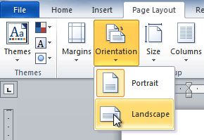

1. Click either **Portrait** or **Landscape** to change the page orientation.

* **Landscape** format means the page is oriented **horizontally**, while **portrait** format means it is oriented **vertically**.

### Page size

* By default, the **page size** of a new document is 8.5 inches by 11 inches. Depending on your project, you may need to adjust your document's page size.
* It's important to note that before modifying the default page size, you should check to see which page sizes your printer can accommodate.

#### To change the page size

* Word has a variety of **predefined page sizes** to choose from.

1. Select the **Layout** tab, and then click the **Size** command.

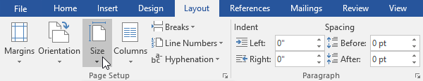

1. A drop-down menu will appear. The current page size is highlighted. Click the desired **predefined** **page size**.

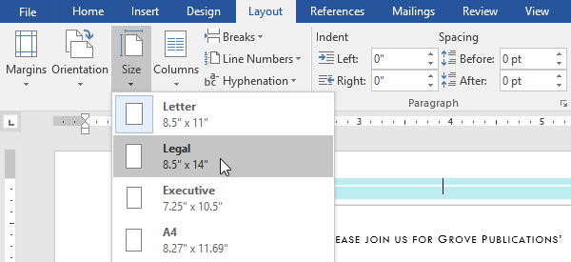

1. The page size of the document will be changed.

#### To use a custom page size

* Word also allows you to customize the page size in the **Page Setup** dialog box.

1. From the **Layout** tab, click **Size**. Select **More Paper Sizes** from the drop-down menu.
2. The **Page Setup** dialog box will appear.
3. Adjust the values for **Width** and **Height**, then click **OK**.
4. The page size of the document will be changed.

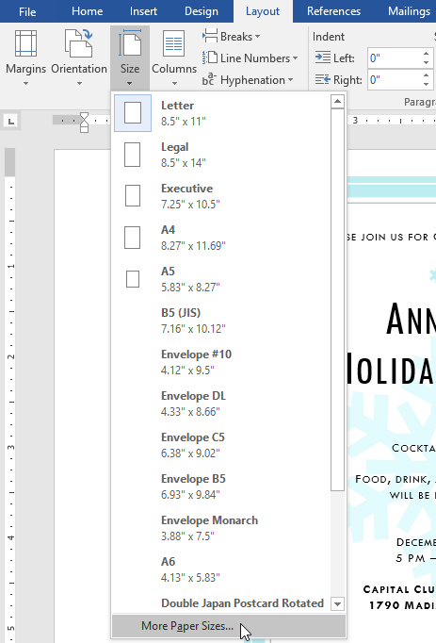

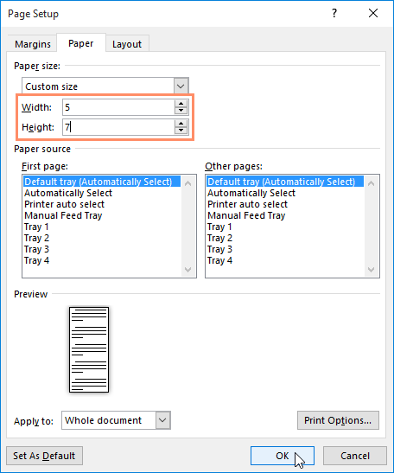

### Page margins

* A **margin** is the **space** between the text and the edge of your document. By default, a new document's margins are set to **Normal**, which means it has a one-inch space between the text and each edge. Depending on your needs, Word allows you to change your document's margin size.

#### To format page margins

* Word has a variety of **predefined margin sizes** to choose from.

1. Select the **Layout** tab, then click the **Margins** command.

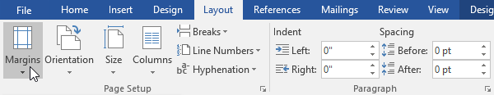

1. A drop-down menu will appear. Click the **predefined margin size** you want.

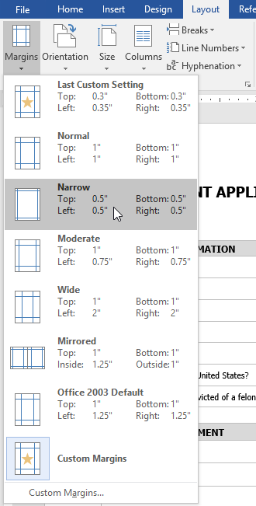

1. The margins of the document will be changed.

#### To use custom margins

* Word also allows you to customize the size of your margins in the **Page Setup** dialog box.

1. From the **Layout** tab, click **Margins**. Select **Custom Margins** from the drop-down menu.

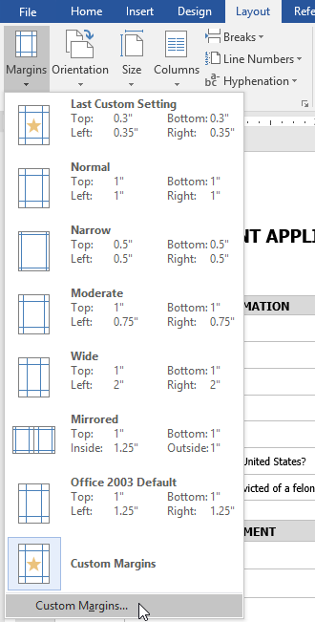

1. The **Page Setup** dialog box will appear.
2. Adjust the values for each margin, then click **OK**.

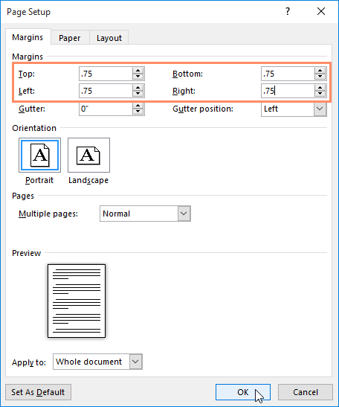

1. The margins of the document will be changed.

* Alternatively, you can open the Page Setup dialog box by navigating to the Layout tab and clicking the small **arrow** in the bottom-right corner of the **Page Setup** group.

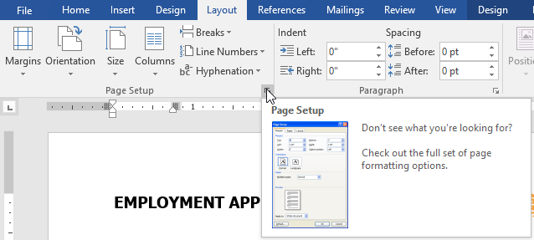

**2.1.2 INSERTING PAGE BREAKS**

* Word has several different types of **breaks** you can add to your document to change the layout and pagination.
* **Page breaks** move text to a new page before reaching the end of a page, while **section breaks** create a barrier between parts of the document for formatting purposes.
* **Column breaks** split text in columns at a specific point.

#### To insert a break

1. Place the **insertion point** where you want the **break** to appear.
2. Select the **Page Layout** tab.
3. Click the **Breaks** command. A menu appears.

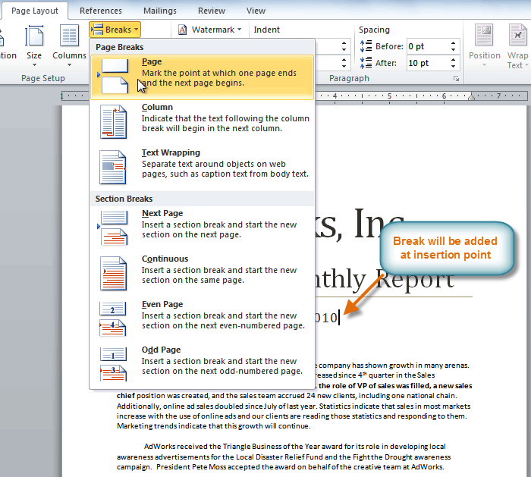

1. Click the desired **break option** to create a break in the document.

#### To delete a break:

* Breaks are **hidden by default**. If you want to delete a break, you'll probably want Word to show the breaks so you can find them for editing.

1. From the **Home tab**, click the **Show/Hide ¶** command.

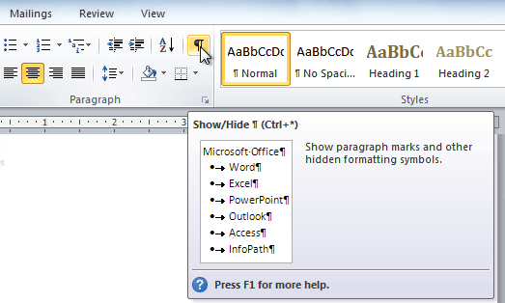

1. **Double-click the break** to select it.



1. Press the **Backspace** or **Delete** key to delete the break.

**2.1.3 BORDERS AND SHADING**

* To decorate a document, use ‘Borders and Shading’ option. For using ‘Borders and Shading’ option, follow these steps:

1. Open desired document.
2. Select the **Page Layout** tab.
3. Click on ‘Page Borders’ option, a dialog will be appear.

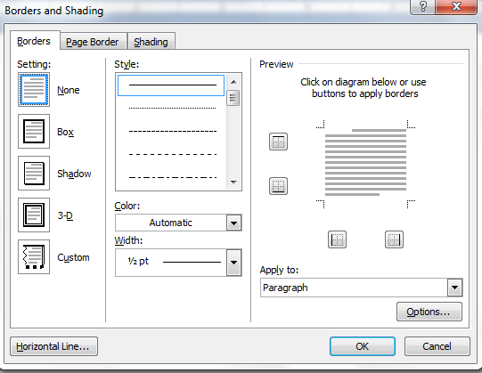

* In ‘Borders’ option, five options are available. To use any option, follow these steps:

1. Select desired part of the document.
2. Choose required option from given five options.
3. Click on ‘OK’ button.

* For example, if choose ‘Box’ option, then it’s effect will be as follows:

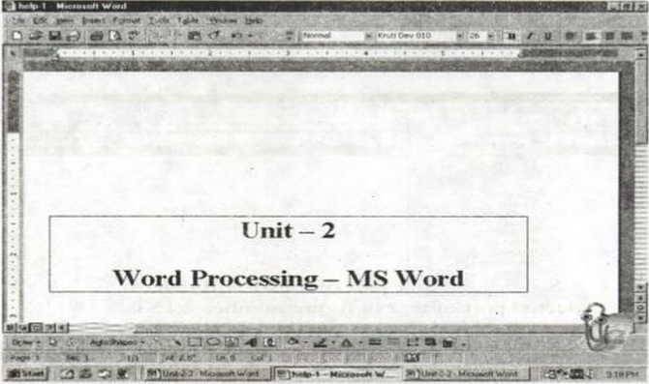

* To use ‘Shading’ option, follow these steps:

1. Select desired part of the document.
2. Click on ‘Shading’ option.
3. Select required colour.
4. Click on ‘OK’ button.

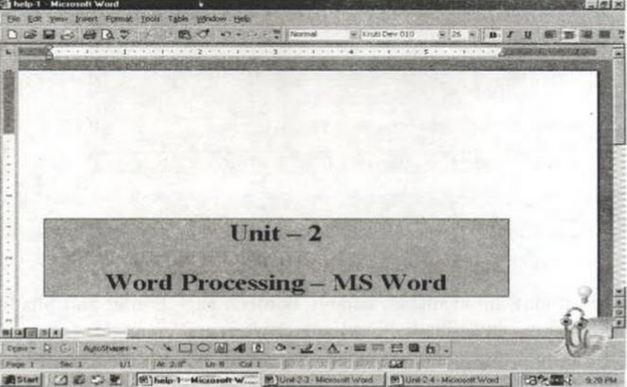

* + 1. **HEADERS AND FOOTERS**
* Use this option to insert page number, file name, author name and all other such type of information related to document.

1. Open desired document
2. Click on ‘View’ menu, a drop down list will open.
3. Click on ‘Header and Footer’ button, many of the layouts appear; see in fig (a).
4. Click any one of the layout that will appear in the text. See in fig (b)

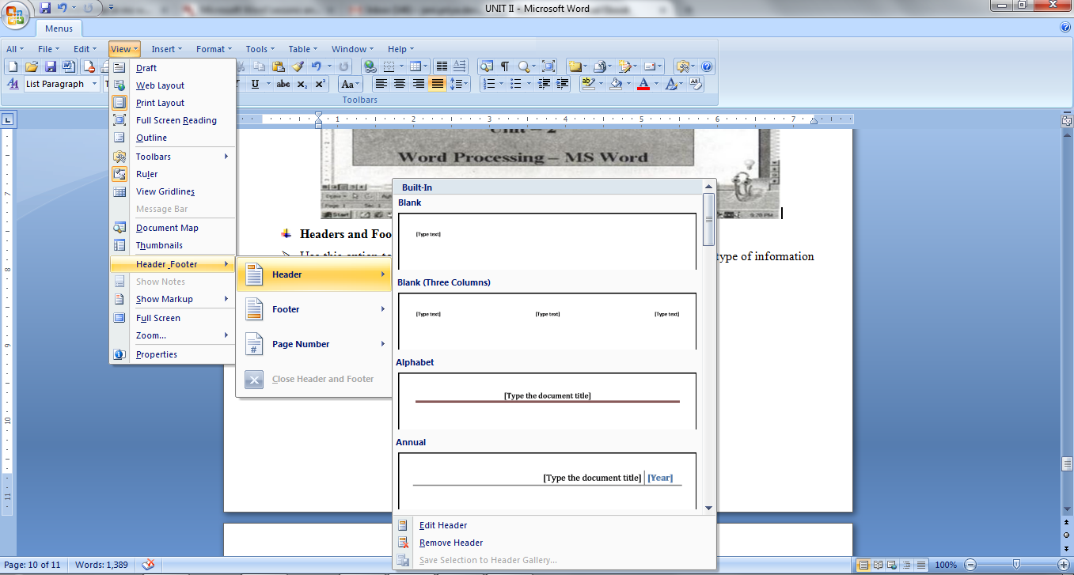

Fig (a)

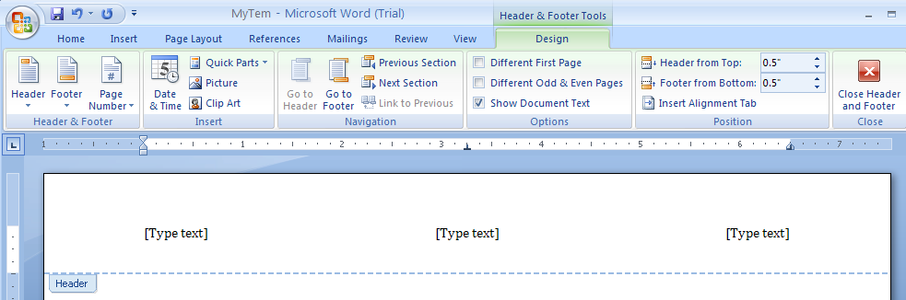

Fig (b)

* 1. **TABLE**

# 2.2.1 Insert Table in MS Word

* Table is a versatile tool of MS Word. It allows you to organize your information, i.e. you can align text, present numerical data and create forms and calendar. The steps to insert table are given below;

1. Place the cursor where you want to insert the table
2. Select the Insert tab
3. In Tables group click the Table command
4. It displays different options to insert the table
5. Select the desired option to insert the table
6. In the Insert Table window that appears, specify the number of rows and column.

|  |  |
| --- | --- |
|  | C:\Users\priya\AppData\Local\Temp\msohtmlclip1\01\clip_image001.png |

**2.2.2 FORMATTING A TABLE**

# Add Row in Table

* If you want to increase or add a new row in your table, you can follow the steps given below;

1. Place the cursor in a row above or below which you want to add row
2. Right click the mouse
3. A menu appears
4. Place the arrow over Insert option
5. It will display a menu
6. As required select 'Insert Rows Above' or 'Insert Rows Below'

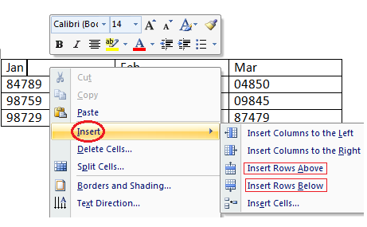

# Add Column in Table

* If you want to increase or add a new column in your table, you can follow these steps;

1. Place the cursor in the column adjacent to which you want to add the column
2. Right click the mouse
3. It displays a menu
4. Place the arrow over Insert option
5. It shows a list of commands
6. As required select 'Insert Columns to the Right' or 'Insert Columns to the Left'

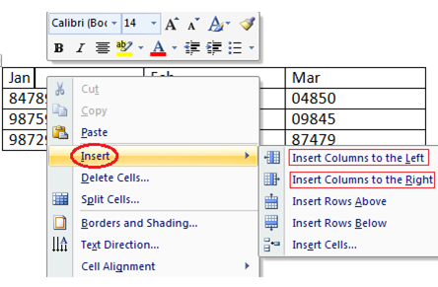

# Delete Column or Row in Table

* The table command also allows you to delete a column or row in your table. You can delete the unwanted columns or rows by following these steps;

1. Select the column or row of the table
2. Right click the mouse
3. A menu appears
4. As required select 'Delete Columns' or 'Delete Rows'

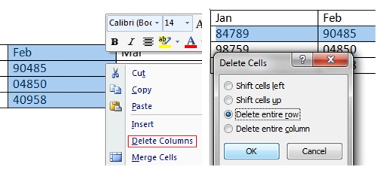

# Modify Table

* Word allows you to customize tables as per your requirement. You can modify your table in different ways, i.e. you can choose a table style, table design, draw borders. The steps to modify a table are given below;

1. Select the table
2. Two new tabs Design and Layout appear on the Ribbon
3. On Design tab you will see three groups of commands to modify table; Table Style Options, Table Styles and Draw Borders;

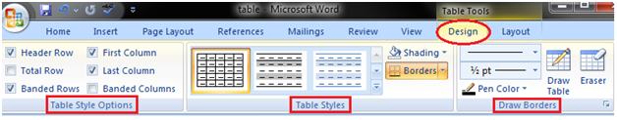

* Layout tab has six groups of commands to format table;

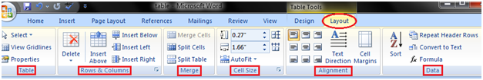

**2.3 WIZARDS AND TEMPLATES**

* Microsoft Word template is a collection of styles which defines paragraph styles for regular text paragraphs, a title, and different levels of headings.
* **Create New Template:**

**Step (1):** To create a new template using an existing template, Click Microsoft Office Button and then click New option which will display Available Templates to be selected.

**Step (2):** Select any of the available template and open it with Template Option turned on.

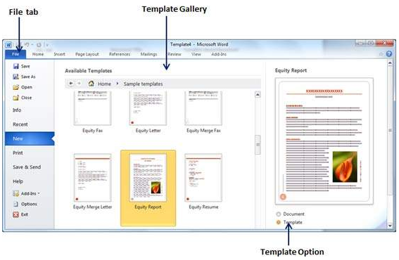

**Step (3):** Now you can modify opened template as per your requirements and once you are done, you are save this template with **.dotx** extension which is standard extension for Microsoft Word Templates.

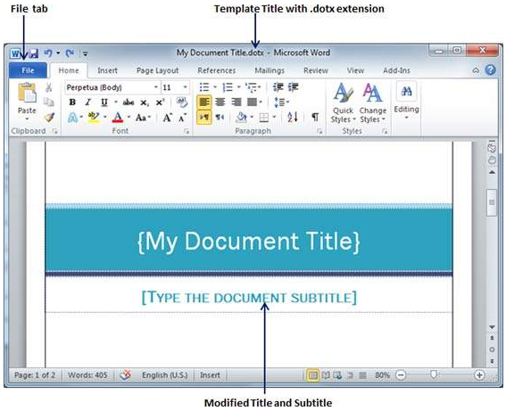

# 2.3.1 HANDLING GRAPHICS

# Insert Clip Art

* Clip art refers to a graphic or a picture that you can insert in your document. The steps to insert a clip art are given below;

1. Place the cursor where you want to insert the clip art
2. Select the Insert tab
3. In Illustrations group click the Clip Art command
4. A task pane appears on the right side of document
5. Enter the keyword in 'Search for' field and select the suitable option in 'Search in' and 'Results should be' fields
6. Click Go, clip art menu will appear
7. Select the desired clip art with a left click
8. Select Insert option. The image should appear in the document.

|  |  |
| --- | --- |
|  | C:\Users\priya\AppData\Local\Temp\msohtmlclip1\01\clip_image001.png |

# Insert Picture in Document

1. Place the cursor where you want to insert the picture
2. Select the Insert tab on Ribbon
3. In Illustrations group click the Picture command;
4. It displays 'Insert Picture' dialog box
5. Select the desired image
6. Click Insert to insert the picture

|  |  |
| --- | --- |
|  | http://content.gcflearnfree.org/topics/233/images_insertpic_dialogbox.png |

# Format Picture or Clip Art

* You can change the appearance of your picture or clip art to enhance its visual impact.
* The format tab offers you various options for formatting pictures like contrast, changing color, line style, cropping, etc. The steps to format picture or clip art are given below;

1. Select the picture or clip art that you want to format
2. Format tab appears in the Ribbon
3. Click the Format tab
4. It displays four groups of related commands to modify or format picture or clip art

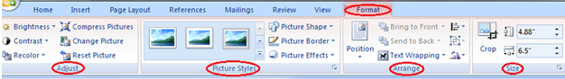

* 1. **Crop a Picture**
* Cropping is used to trim the sides of a picture. This is useful when you only want to use a portion of the picture.

1. Click on the picture to select it
2. Click the **Crop** button in the Size group of the Format contextual tab on the Ribbon
3. Click the **Crop** button in the Size group of the Format contextual tab on the Ribbon

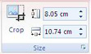

1. Crop handles appear around the edges of the graphic. Click and drag the handles in to trim the necessary sides

• 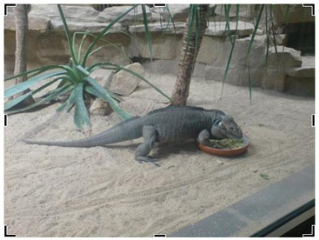

1. Word crops the picture. Click the **Crop** button again to turn off the cropping tool

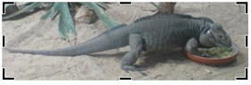

* 1. **Recolor a Picture**
* There are a variation of colours you can use for your pictures in Word 2007. Popular colours are grayscale or washout.

1. Click on the picture to select it
2. Click the **Recolor** button in the Adjust group of the Format contextual tab on the Ribbon
3. A list of colour options appears. Select the colour you want to use

|  |  |
| --- | --- |
| Recolor options |  |

1. **Change the Picture Style**

* Word 2007 comes with some built-in styles that change the appearance of your graphic at the click of a button.

1. Select the picture
2. Select the style you want to use from the Styles gallery in the Picture Styles group of the Format contextual tab on the Ribbon

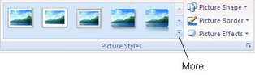

1. Click the **More** button to see full list of styles available
2. **Apply Special Effects**

* Special effects such as glow, reflection, shadow and bevel can be applied to your Word pictures.

1. Select the picture
2. Click the **Picture Effects** button in the Picture Styles group of the Format contextual tab on the Ribbon
3. Select the effects you want to apply from the list and then the submenu that appears

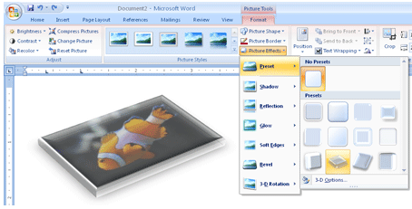

1. **Change Picture Brightness and Contrast**
2. Select the picture
3. Click on the **Brightness** or **Contrast** button in the Adjust group on the Ribbon
4. Select the option from the list that you want.

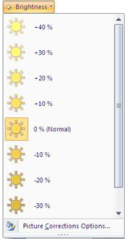

# Insert Smart Art Graphics

* You can insert Smart Art Graphics in your document to effectively communicate your message.
* You can insert a process flow, a relationship or an organization hierarchy. The steps to insert smart art graphics are given below;

1. Place the cursor in the document where you want to insert graphics
2. Select the Insert tab
3. Select the 'Smart Art' or ‘Diagram’ command; a dialog box appears with list of categories
4. Select the desired illustration and click Ok.

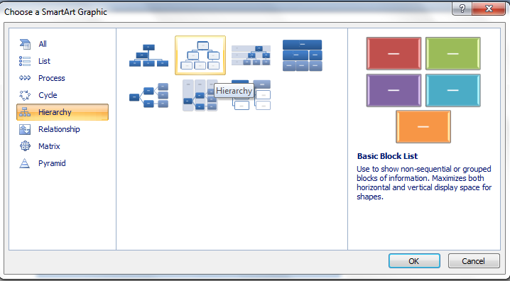

# Add Text in Smart Art Graphics

* Word also allows you to add text in Smart Art Graphics; you can add facts, figures and any other information. The steps to add smart art graphics are given below;

1. Select the graphic
2. Task pane appears on the left side if it is not visible then click the arrow on left side of graphic
3. Type the text in task pane fields it will appear in the graphic
4. You can also directly type the text in the graphic in text area
5. Close the task pane after entering the text and click outside the graphic.

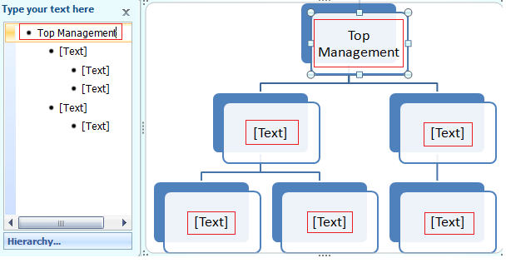

* 1. **MAIL MERGE**
* Mail merge is a tool which allows you to create form letters, mailing labels and envelopes by linking a main document to a data source.
* It is the process of combining a list of data with a template.
* The mail merge process involves the following:
* **The Main Document** – contains the text and graphics that are the same for each version of the merged document
* **Data Source** – a file that contains the information to be merged into a document. For example, the names and addresses of the recipients of a letter.
* **Mail Merge – Form Letters**
  + 1. Open **Microsoft Word** and create a new blank document
    2. Type the letter with all needed text and formatting, leaving room for the data from the data source (example: name, address, etc)
    3. Click **Mailings** tab
    4. Click **Start Mail Merge**
    5. Click **Step by Step Mail Merge Wizard**

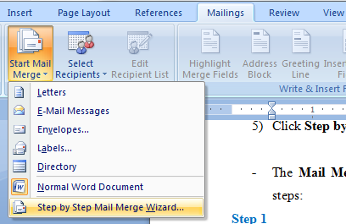

* The **Mail Merge task pane** appears on the right of your screen. Note there are 6 steps:

**Step 1**

1) Click **Letters** for the document type

2) Click **Next: Starting document**

**Step 2**

1) Click **Use the current document** under **Select starting document**

2) Click **Next: Select recipients**

**Step 3**

* The recipients can come from either an existing Excel file, an Access table or you can create a new list in Word.

1) Click **Use an existing list** under **Select recipients**

2) Click **Browse**

3) Select the file

4) Click **Open**

5) Select the worksheet tab name that contains the data

6) Click **OK**

**Mail Merge Recipients** opens showing the file data

7) Click **OK**



8) Click **Next: Write your letter**

**Step 4**

1) If including an address, click the location in your document where the address data will be inserted

2) Click **address block…**

3) Select the address elements you want included

4) Click **OK**



* The field name will look like this: **<<AddressBlock>>**
* The address block will insert the following fields including any necessary punctuation: First Name, Last Name, Company, Address 1, Address 2, City, State, and Postal Code.
* If your fields do not match the ones listed above or you are not using address fields, click **More items…**



5) Click on the field from the list

6) Click **Insert**

7) Click **Close**

The field name will look like this - **«First\_Name»**

8) Repeat this step until all fields have been inserted.

9) Click **Next: Preview your letters**

**Step 5**

* Here is where you can preview the first page with the fields filled in.

Click **Next: Complete the merge**

**Step 6**

**To Complete the Merge:**

1) Click **Print** to send directly to the printer

2) Click **Edit individual letters** to create a new file

**2.4.1 MAILING LABELS**

1) Create a new blank document

2) Click the **Mailings** tab

3) Click **Start Mail Merge**

4) Click **Step by Step Mail Merge Wizard**

**Step 1**

1) Click **Labels** for the document type

2) Click **Next: Starting document**

**Step 2**

1) Click **Label options** under **Change document layout**

2) Choose the label style you are using

3) Click **OK**



4) Click **Next: Select recipients**

**Step 3**

1) Click **Use an existing list** under **Select recipients**

2) Click **Browse**

3) Select the file

4) Click **Open**

5) Select the worksheet tab name that contains the data

6) Click **OK**

7) Click **Next: Arrange your labels**

**Step 4**

1) Click in the first label box and click on either **Address block** or **More items** to insert the data fields

2) Click **Update all labels** to include the fields on all labels

3) Click **Next: Preview your labels**



**Step 5**

Here is where you can preview the labels.

Click **Next: Complete the merge**

**Step 6**

Click **Print** to send directly to the printer

*OR*

Click **Edit individual labels** to create a new file